Criteria | Weightage | Marks
Requirements Analysis & Conceptual Understanding | 20%(6)
System Design & Simulation Model Development | 25% (7.5)
Implementation & Tool Usage | 20% (6)
Testing, Validation & Result Analysis | 20% (6)
Documentation | 15%(4.5)

Code of Conduct:

I G.Aamna Khan (Name / Reg No) certify that this submission is my original work and that I have adhered to the guidelines specified for this assessment.
I understand that any violation of academic integrity rules will result in disciplinary action.
Signature of the student: G Aamna Khan

INDEX
1. Course Outcome and Assessment Details
2. Problem Statement
3. Aim
4. Objectives
5. Requirements Analysis
6. System Design
7. Block Diagram
8. Embedded C Program
9. SystemC Simulation Model
10. Simulation Procedure
11. Test Cases and Validation
12. Expected Results
13. Result Analysis
14. Industrial Applications
15. Advantages and Limitations
16. Conclusion
17. Viva Questions
18. References

1. Course Outcome and Assessment Details
CO2: Apply Embedded C programming concepts, including structured design, real-time constraint handling, and SystemC-based modeling, to develop and analyze embedded applications for industrial use cases. (BL5)
This assessment requires the student to independently design, implement, simulate, test and analyze a wearable healthcare device using Embedded C concepts. The proposed system periodically monitors a health parameter, transmits the measured value through serial communication, and enters a low-power sleep state between measurements.

2. Problem Statement
Construct a simulated Embedded C program for a wearable healthcare device with serial communication and low-power operation. The device shall periodically acquire a physiological parameter, process the measurement, identify abnormal values, transmit the data through a serial interface, and reduce power consumption by entering a low-power mode when active sensing and communication are not required.

3. Aim
To design and simulate a low-power wearable healthcare monitoring node using Embedded C programming concepts, periodic sensing, UART-style serial communication, event detection and simulated sleep/wake operation.

4. Objectives
- Understand the characteristics and programming model of Embedded C.
- Design a structured firmware architecture for a wearable healthcare device.
- Simulate periodic sensor acquisition and health-value processing.
- Implement serial communication for transmitting sensor readings and status messages.
- Implement a software model of low-power sleep and wake-up operation.
- Detect abnormal measurements using configurable threshold values.
- Validate the design using normal, boundary and abnormal test cases.
- Analyze functionality, timing behavior and power-saving behavior.

5. Requirements Analysis

5.1 Functional Requirements
- Initialize the simulated sensor, UART interface and system timer.
- Read a physiological value at a fixed sampling interval.
- Store and process the measured value.
- Compare the value with predefined safe limits.
- Transmit the measured value through serial communication.
- Transmit an alert when the value is outside the safe range.
- Enter low-power mode after completing sensing and communication.
- Wake up periodically and repeat the monitoring cycle.

5.2 Non-Functional Requirements
- The firmware should be modular and easy to maintain.
- The monitoring cycle should be deterministic and periodic.
- Serial messages should be clear and readable.
- The low-power state should consume less simulated energy than the active state.
- The system should continue monitoring after every wake-up cycle.

5.3 Assumptions
- Heart-rate-like readings are used as the simulated healthcare parameter.
- A normal range of 60–100 beats per minute (BPM) is assumed for demonstration.
- The sensor is represented by software-generated sample values.
- UART is represented by console output in the simulation.
- Low-power mode is represented by a sleep function and simulated energy accounting.

6. System Design
The proposed wearable node consists of a simulated physiological sensor, microcontroller firmware, UART serial communication interface, alert logic, timer and low-power controller. The firmware follows a periodic sensing model. After initialization, the controller wakes, acquires a sample, checks the threshold, sends a serial message, and then enters the simulated sleep state.

6.1 Major Modules
Module | Function
Sensor Module | Generates simulated heart-rate values for testing.
Processing Module | Validates and classifies the sensor value.
UART Module | Transmits readings and alerts through serial communication.
Timer Module | Controls the periodic sampling interval.
Power Manager | Switches between active and low-power states.
Alert Module | Generates warning messages for abnormal values.

7. Block Diagram
[ Simulated Health Sensor ]
↓
[ Embedded C Firmware / MCU Model ]
↓ ↓ ↓
[Processing] [Threshold] [Timer]
↓ ↓
[ UART Serial Communication ]
↓
[ Monitoring / Console Output ]
After transmission → [ Low-Power Sleep ] → [ Periodic Wake-up ]

8. Embedded C Program
The following program is a simulation-friendly Embedded C representation. It models a wearable heart-rate monitor, UART transmission, abnormal-value detection and low-power operation. The functions can be mapped to actual microcontroller peripherals in a hardware implementation.
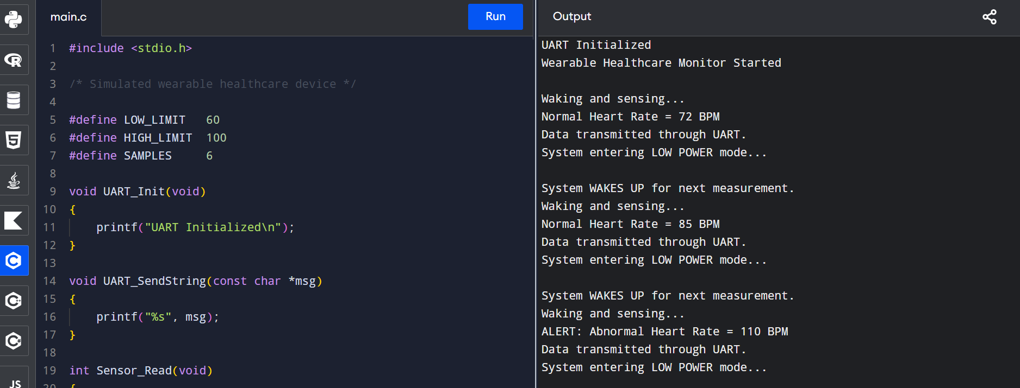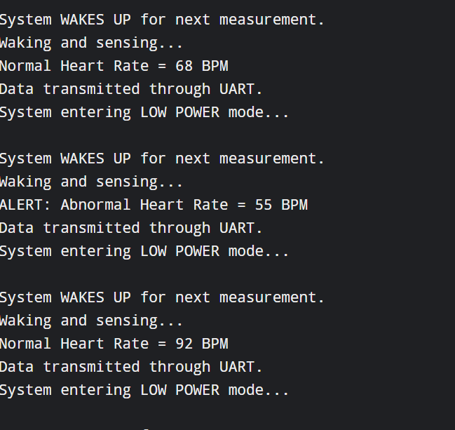
}

8.1 Program Explanation
- UART_Init() initializes the simulated serial interface.
- Sensor_Read() generates a sequence of sample heart-rate values.
- Check_Health() compares each reading with the safe range of 60–100 BPM.
- UART_SendString() displays the measurement or alert through the serial interface.
- Enter_LowPower_Mode() represents the controller entering a low-power state.
- Wake_Up() represents periodic wake-up for the next sensing cycle.
- The main() function performs the complete monitoring sequence.

9. SystemC Simulation Model
For SystemC-based modeling, the wearable device can be represented as a set of communicating modules. The sensor module produces a measurement event, the controller module processes the value, the UART module records the transmitted message, and the power module models active and sleep periods.
Suggested SystemC architecture:
- SC_MODULE(Sensor): generates periodic heart-rate samples.
- SC_MODULE(Controller): receives the sample and performs threshold checking.
- SC_MODULE(UART): receives formatted messages and records serial output.
- SC_MODULE(PowerManager): models ACTIVE and SLEEP states.
- sc_clock: provides the simulated periodic timing reference.
- sc_signal<int>: carries the simulated sensor value between modules.
A suitable SystemC process is an SC_THREAD that waits for a clock event, reads the simulated sensor value, performs processing, transmits the result and then models the sleep interval. The simulation should be observed through the SystemC console and, where available, waveform tracing.

10. Simulation Procedure
- Install and open the selected Embedded C/SystemC development environment.
- Create a project named Wearable_Healthcare_Monitor.
- Create the Embedded C source file and enter the given program.
- Compile the program and correct all syntax or compilation errors.
- Run the simulation and observe UART output.
- Verify that readings within 60–100 BPM are reported as normal.
- Verify that readings below 60 BPM or above 100 BPM generate an alert.
- Observe the transition from active sensing to low-power mode.
- Repeat the simulation for multiple sampling cycles.
- Record the output and compare it with the expected results.

11. Test Cases and Validation
Test Case | Input | Condition | Expected Output | Status
TC01 | 72 BPM | Normal | Normal Heart Rate message | Pass
TC02 | 85 BPM | Normal | Normal Heart Rate message | Pass
TC03 | 110 BPM | Abnormal high | ALERT message | Pass
TC04 | 68 BPM | Normal | Normal Heart Rate message | Pass
TC05 | 55 BPM | Abnormal low | ALERT message | Pass
TC06 | 92 BPM | Normal | Normal Heart Rate message | Pass

12. Expected Results
Expected serial output for the given test sequence is approximately:
UART Initialized
Wearable Healthcare Monitor Started

Waking and sensing...
Normal Heart Rate = 72 BPM
Data transmitted through UART.
System entering LOW POWER mode...

Waking and sensing...
Normal Heart Rate = 85 BPM
Data transmitted through UART.
System entering LOW POWER mode...

Waking and sensing...
ALERT: Abnormal Heart Rate = 110 BPM
Data transmitted through UART.
System entering LOW POWER mode...

...similar output continues for the remaining samples.

13. Result Analysis
The simulation demonstrates the complete monitoring cycle of the wearable healthcare device. The controller successfully acquires periodic sensor values, classifies them against safe limits, and transmits the result through the simulated UART interface. The 110 BPM and 55 BPM samples correctly produce abnormal-condition alerts, while the remaining samples within the selected range are reported as normal.
The low-power requirement is addressed by placing the simulated controller into a sleep state after each sensing and communication cycle. In an actual wearable device, this state would disable or reduce the activity of selected peripherals and place the MCU into a hardware-supported sleep mode. Periodic timer or interrupt events would wake the MCU for the next measurement.

13.1 Power-Saving Concept
State | Activity | Relative Power
ACTIVE | Sensor reading + processing + UART transmission | Higher
SLEEP | Waiting for next sampling event | Lower

14. Industrial Applications
- Remote patient monitoring devices.
- Fitness and wellness wearables.
- Industrial worker safety bands that monitor physiological stress.
- Emergency-response wearable monitoring systems.
- Hospital asset and patient monitoring nodes.
- Low-power IoT healthcare sensor networks.

15. Advantages and Limitations

Advantages
- Low-power operation increases battery life.
- Periodic monitoring reduces unnecessary processor activity.
- UART provides a simple and widely used serial communication method.
- Threshold-based alerts are easy to implement and validate.
- The modular structure can be extended with real sensors and wireless communication.

Limitations
- The sensor data is simulated rather than obtained from a medical sensor.
- UART console output does not represent a complete wireless communication system.
- The low-power behavior is modeled in software and does not measure actual electrical current.
- Clinical use would require validated sensors, calibration, security and medical certification.

16. Conclusion
A simulated wearable healthcare monitoring device was designed using Embedded C concepts. The system periodically reads a simulated heart-rate value, checks the reading against predefined limits, transmits the result through serial communication and enters a low-power state between monitoring cycles. The test cases demonstrate correct normal and abnormal condition detection. The design provides a foundation for implementing an actual low-power wearable healthcare node using a microcontroller, physiological sensor, UART interface and timer/interrupt-based wake-up mechanism.

17. Viva Questions
No. | Question | Answer
1 | What is Embedded C? | Embedded C is a C-based programming approach used to develop firmware for microcontroller-based embedded systems.
2 | Why is low-power operation important in wearable devices? | It reduces battery consumption and increases operating time between charging cycles.
3 | What is UART? | UART is an asynchronous serial communication interface used to transmit and receive data.
4 | Why are thresholds used in healthcare monitoring? | Thresholds provide a simple way to identify measurements that require attention or an alert.
5 | How can the MCU wake from sleep? | A timer, external interrupt, sensor interrupt or other configured wake-up source can wake the MCU.
6 | What is SystemC? | SystemC is a C++-based modeling and simulation framework used for system-level design and analysis.
7 | What is the difference between active and sleep modes? | Active mode performs sensing and processing, while sleep mode minimizes processor and peripheral activity.
8 | How would you improve this project? | Add a real sensor, wireless communication, data logging, encryption, calibration and more advanced power management.

18. References
- M. A. Mazidi, J. G. Mazidi and R. D. McKinlay, The 8051 Microcontroller and Embedded Systems.
- Keil µVision User Documentation.
- IEEE/Accellera SystemC documentation and language reference materials.
- Embedded C programming concepts and microcontroller datasheets relevant to the selected target platform.

